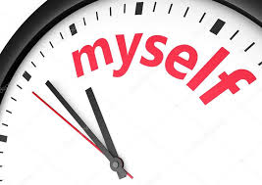**DISTRICT 2 FUN DAY**

**“A LITTLE TIME FOR MYSELF”**

**WHEN**: SATURDAY NOV 2, 2024

**WHERE:** **SPENCER AL-ANON CLUBHOUSE**

(511 Southmoor Drive, Spencer)

**TIME**: 1:00 p.m.-4:00 p.m.

Bring a friend, a dessert to share,

the book: “A Little Time for Myself”

Coffee and water will be provided

COSTUMES OPTIONAL

