SERENITY WEEKEND
PLANNING MEETING
BRING THEME IDEAS
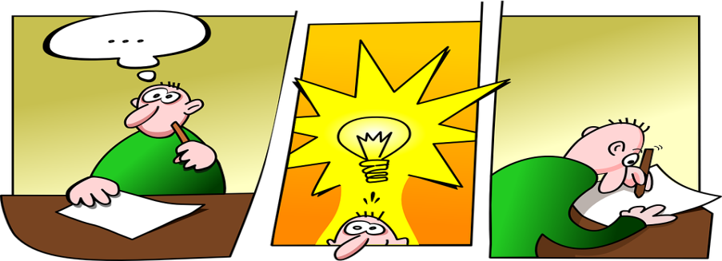
MARCH 4, 2023
Marshalltown Library
105 West Boone St.
Meeting Room A
1:30 – 3:30 PM (possibly longer)

Bring ideas, friends and snacks to share!

